INFO2222

Usability

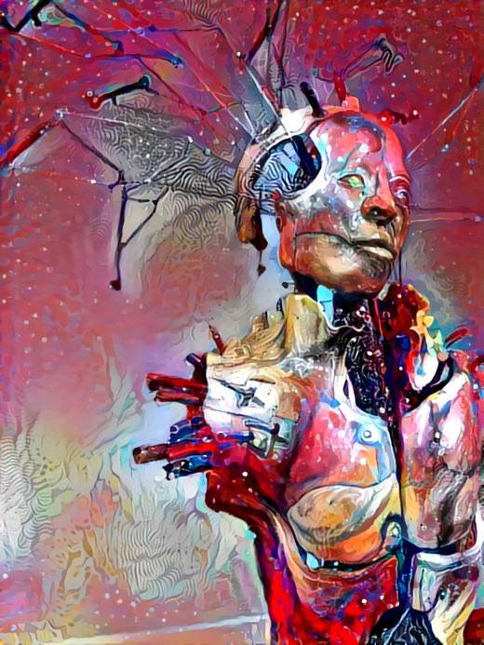

Ali Haider Kachwalla

Table of  
Contents

Step 1 1

Investigation process 1

PACT Analysis 3

People 3

Activities 3

Context 4

Technologies 4

Persona 5

Step 2 7

Card sorting session 7

Website information architecture 8

step 3 10

Prioritised list of additional features 10

Steps to determine the ‘best’ design to be prototyped 10

Which user specified feature? 11

What was our target user like? 11

What did people think? 11

Paper prototype 12

Guerrilla test (how, materials, results, findings) 13

step 4 14

Usability improvements from part 1 14

Adding and removing admins and users 14

Data information hierarchy 15

Specific user function (Iteration 1) 15

Specific user function (Iteration 2) 17

# Step 1

Step 1 involved creating a persona of the target user. This is done using user investigation such as surveys and interviews along with a PACT analysis.

## Investigation process

The investigation process was initially done through a Google survey, the excel results for which have been included below. These were used to understand about the target user demographic and their wants/needs.

With specified users who had large requests, I also scheduled interviews to understand more about what they would like me to build. Additionally, it was during these interviews that I conducted a PACT analysis due to in-depth questioning and observation needed, which wasn’t appropriate for a survey.

With the 30 survey responses I collect, some trends become evident. The most telling graph applied throughout the report is presented below.

Some important notes in advance are that the red section is Endorsed/Important threads along with anonymous threads (unable to be shown due to the length of the title.

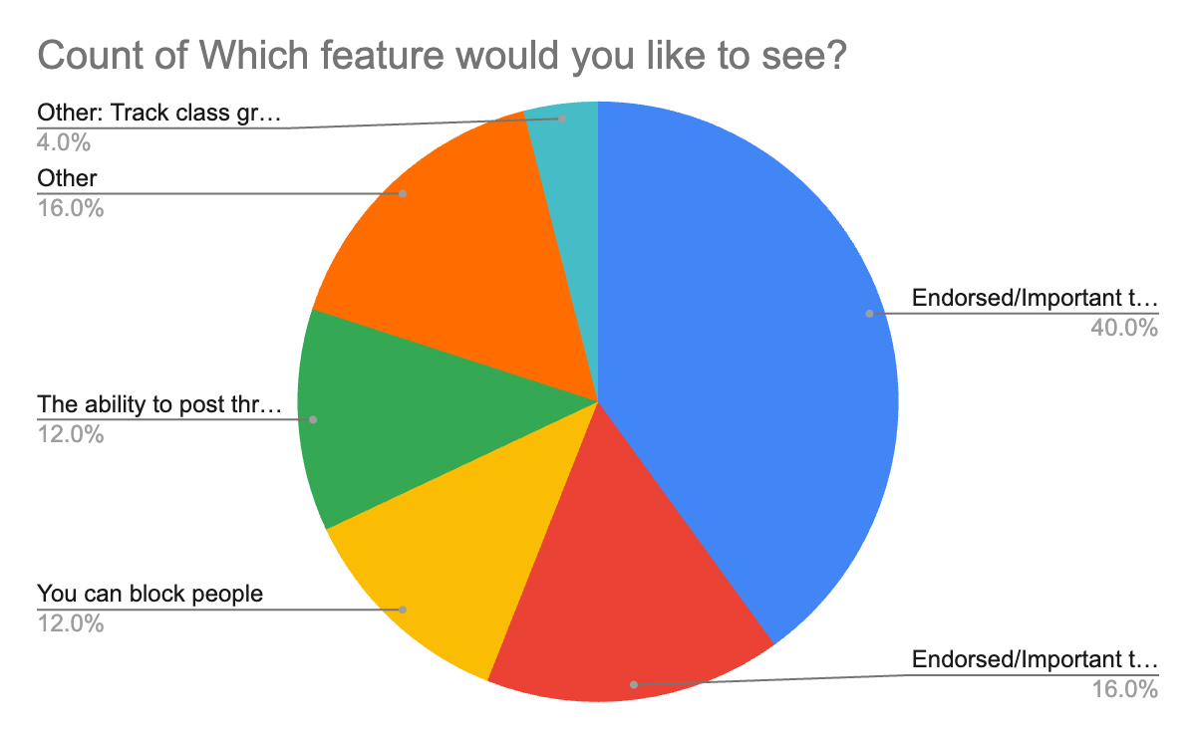

From this graph, it can be seen that 56% of people wanted to see important threads. This was the majority requested function. The second most requested function with 28% was the ability to post threads anonymously. Blocking people came in at 12% however it was also included in the admin controls thus not implemented.

Some other interesting statistics were that 86.7% of the sample population did not require any special considerations. There was one response which required high contrast while the remaining unaccounted for were the need for using different languages. The majority of the participants were either completing commerce, advanced computing or both, and on average, arts and design students use Ed the least, in comparison to the others.

Survey results:

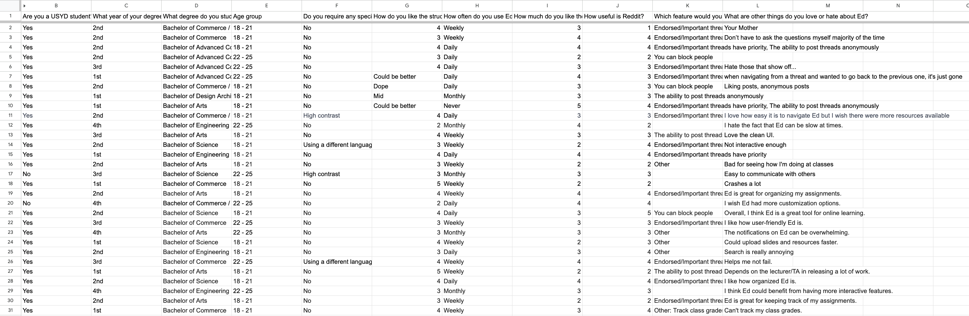

## PACT Analysis

A PACT analysis is a framework often utilized in people-centric design. It has 4 main components, People, Activities, Context, and Technologies. Through my user investigation process, I have narrowed these down.

The below PACT analysis is done based on the majority of the userbase. There will always be exceptions to below.

### People

Who were the people involved?

* Able to remember and compute mathematical equations in their heads
* Right-handed
* Without glasses
* Able to focus through the entire interview
* Used the system to keep on top of course content and assignments
* Highly motivated to not fail the subject

### Activities

What did people want to do?

* People used the service daily while they were studying, normally to seek help or to check for notifications
* Browsing forums and chats are often interrupted before being returned to later
* The activity can be done alone, although people tend to spend more time if it is done with someone else (even virtual via the messaging)
* Uncomplicated
* There is normally an edit functionality in these types of apps allowing for mistakes to be made, meaning there are no critical consequences

### Context

Contextually, where does the interaction take place?

* Physically, it normally occurs in the standard study spot, this varied between the library, cafes and home
* Socially, this is normally done while alone, although there was mention of doing it while studying with others
* USYD requires that a standard of decency be maintained, and posts are actively monitored to ensure no unfair advantage is given

### Technologies

What technologies were involved?

* Users input questions or answers into the knowledge repository, this is often done with images to showcase exactly what is being talked about
* A similar process is shown in the messaging system, with contents being extremely tied with the focus of study (due to the nature of the platform)
* Users view course material along with the posts and messages of other users
* All content is user-generated, with course materials generated and maintained by administrative users

## Persona

|  |  |
| --- | --- |
|  | Average Surveyed Student |
| Photo | Name:  Jerry Schmerry |
| Current Role | B. Advanced Computing  (Simultaneously thinking about a double degree or dropping to B. Computing)  2nd Year USYD student |
| Demographics | 18-21  Highschool Level Education  No disabilities that impact the use of Ed  Uses technology constantly |
| Goal and Task | Uses the website every day for a few reasons:   * Programming help * Looking at questions others have posted * Not missing out on assignments |
| Environment | Tech savvy, access to minimum 1 phone and laptop, with a high likelihood of a desktop computer or a tablet as well Varied home background |
| Quote | “Just keep swimming” - Dory |

From the creation of the target persona, the need to follow standard industry practices in website design became obvious. Additionally, there were a few key pieces of content which users wanted:

* Questions posted by other users
* Assignment notifications

These were included and factored into the later decision on which user specified function to build.

Users also wanted to be able to post anonymous threads, which was factored in as a design consideration later in the process.

# Step 2

Step 2 consists of creating a sitemap. This is informed by opened and closed card sorting, creating a holistic information architecture.

## Card sorting session

The card sorting session was used to determine what information would be put into each page. This was facilitated through the use of the online card sorting tool kardsort. The groups pages given were: Main page, Course Guides, Course Home, Account, Help, Login and Messages.

The information to be sorted was: Conversations, Knowledge repository, Threads, Change password, About page, Reporting bugs, Lock account, View credentials Reporting bugs, How-tos, Login, Create account, Admin abilities, Courses and Messages.

The website information architecture is implemented from the closed card sorting as in open card sorting, people became increasingly unbothered. One trend seen in open card sorting was very few pages, coming down to this grouping. All account settings (including admin page) together, messages and knowledge repository together. This two-page system does not adhere to the usability principles presented so far in the course and while it was the most presented, it was not referred to. When asked about the pages however, the ask for an admin page was posed, thus it was implemented in the closed card sorting.

## Website information architecture

Main page

* Courses
* Messages

Course Guides

* Individual courses (linking to the knowledge repository)

Course Home

* Endorsed/Important threads
* Answered questions

Account

* Change password
* View credentials
* Lock account (no one can access it)

Admin

* Add or remove users from courses
* Add or remove users as administrators
* Manage users

Help

* About page
* Reporting site bugs (tells you to post on forums or message an admin)
* Site how-tos

Login

* Login credentials
* Create account

Messages

* All chat conversations

The above information is the synthesized card sorting session. This information is then represented in the information architecture diagram below, with some links being made to allow for a smoother user experience.

The information architecture holistically considers many usability concepts. It follows general trends in messaging platform design (such as Ed and messenger apps, which were shown to be liked through the user investigation process) to improve learnability and memorability. The use of a header bar will also increase efficiency and user satisfaction along with error recovery is implemented through processes in which users can ask for assistance from administrators.

# step 3

Step 3 involves guerrilla testing a wireframe prototype. Along with this, a prioritized list of additional features is created outlining next development steps.

## Prioritised list of additional features

After examining the results of the survey and the core requirements, the prioritized list of additional features is as follows.

1. Data/Information hierarchy – The threads themselves will be stored according to time
2. Admin role – This included the implementation of the admin page along with the user feature
3. User specified feature – The feature implemented was the ability to endorse threads, prioritizing them and showing how helpful they were to others

## Steps to determine the ‘best’ design to be prototyped

There were many ideas to be prototyped. To find the best idea it was necessary to narrow down a few things.

### Which user specified feature?

There was a myriad of presented user specified features, however, through our data collection, the two clear winners were:

1. Endorsed threads
2. Private threads

These both had a similar number of votes, although endorsed was slightly in the lead. Our user investigation had also shown that people used Ed for a few main reasons, with a common answer being to look at the questions posted by others. Another reason was due to assignment notifications often being posted there. Thus, these reasons led to the prioritization of the endorsed threads feature, as it would allow users to sift through the Ed threads and find those with key and/or helpful information.

### What was our target user like?

Our target user is the average USYD student. From data collection, this is someone heavily engaged with technology, related and unrelated to study. Additionally, the most common age group was from 18 – 25. Social media plays a large role in the technology use of this age group. Due to this, designs were scrapped as their use would not be intuitive for someone with that background. Additionally, elements from prominent social media sites were also incorporated. These elements include taking inspiration for site design and navigation.

### What did people think?

The final step was to talk people through the iterations of our design, narrowing down on one to create a paper prototype of.

## Paper prototype

Pasted below is the paper wireframe prototype. This was created after synthesizing data from user collection and personal research.

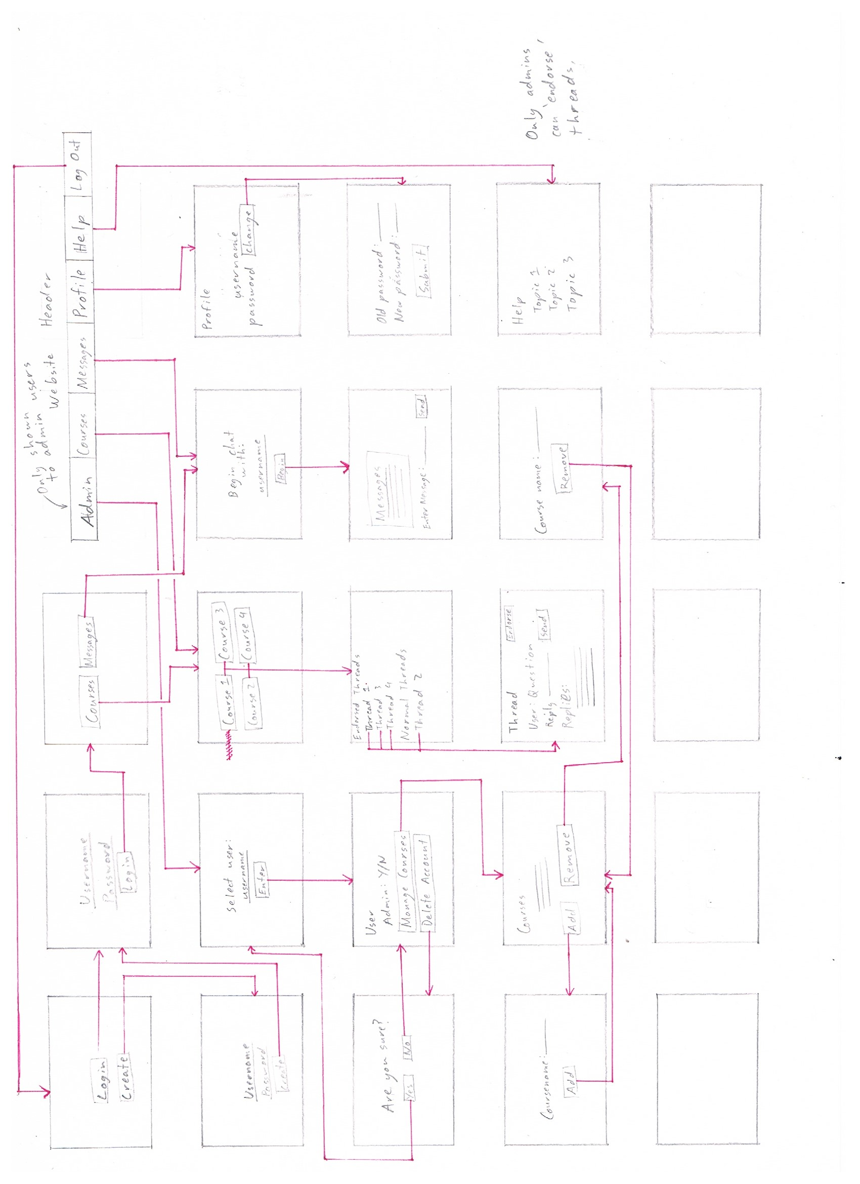

## Guerrilla test (how, materials, results, findings)

For the guerrilla test, I used the above wireframe sitemap. With this, I asked a general set of questions:

* What do you think about this website?
* Would you use this website?
* Is there anything you would like to improve about this website?

There was a wide variety of feedback which I will synthesise below.

The most common piece of feedback was that the site was not pleasing to look at. This concern was put to rest by specifying that this website was in fact a low-fidelity prototype.

Another concern that was brought up was the fact that there were too many Windows. However, after properly going through each window, this concern was not really there anymore. Although there was the suggestion that certain screens could easily be displayed as popups.

In the question whether they would use the website, a common answer would be that if mandated, it would be easy to use as the UI mirrors existing solutions such as Edstem. However, there were a few places (such as selecting username) which were text input where those interviewed would have preferred a dropdown. One person would have preferred the entire list to be displayed however after understanding scale, they no longer posited that idea.

One notable thing that I could improve was image support. This includes profile photos, and the ability to post images in threads. While this is an extremely valid comment, in the context of this task, I was not able to implement image support.

# step 4

Step 4 consists of demoing the final website and testing with a target group. Feedback is incorporated to create a final product that is learnable, efficient, and memorable. It incorporates error recovery and user satisfaction, with an incremental development plan showing improvements in each iteration.

## Usability improvements from part 1

From part 1, the usability improvements I created were about integrating the forum component into the website. Additionally, the website was reorganised based on the card sorting sessions, converting it so that it was the most user friendly possible. Finally, using the survey results, I remade the website to follow more mainstream website designs such as Ed, Reddit and Facebook. This helped with users recognising how to utilise the website.

## Adding and removing admins and users

Users are added through creating an account and the first admin user is system created. This admin user can then add other admins. Each admin has the power to add or remove admins. They can also control users. Adding or removing them from courses, or even deleting their accounts.

This administrator control is done through the admin page only accessible to administrator users.

## Data information hierarchy

The pages with information relevant to the target user are courses and messages. Both pages order content in terms of recency. Course forums also have the option to endorse certain threads, making them more visible to other users due to having that tag.

While there are other pages that are also relevant to the target user however they do not really organise the information in any way, due to there not being much information to organise. These pages however did adhere to POUR principles (perceivable, operable, understandable & robust).

The pages created were perceivable due to good design principles and operable as the designed principles implemented are followed industry wide. The pages are understandable as each has a purpose and robust as each purpose is extremely specific.

## Specific user function (Iteration 1)

The specific user function I am describing in iterations is the ability to endorse threads. The ability to post anonymously was also implemented however did not show a need for iteration. In this first iteration, I implemented the function only for administrators. Regular users could still press the button; however, it wouldn’t do anything.

Testing this with a trial group, many found the fact that the button existed to be a relief. To make this a fair test, I randomly allocated administrator and user accounts to participants, with their feedback recorded in the table below.

|  |  |  |
| --- | --- | --- |
|  | Administrator | User |
| Positive | Threads I find important I can now flag for everyone else. | The feature is implemented and allows me to feel like I’m adding to the community. |
| Negative | Every second thread is getting flagged as important even when irrelevant. | While there is a button, it doesn’t seem to do anything, leading to a feeling of futile actions. |
|  |  |  |

After explaining the differences between accounts, there was one common piece of feedback from the majority of participants. Administrators may want to see different things from users.

Thus, the focus of the next round of implementation was on ensuring that users could have their voices heard, while still giving administrators priority in endorsing. There will also be the implementation of the ability to post anonymously.

Additionally, the first iteration was solely focused on ensuring that the functionality was present. This is shown through an example screenshot below. The usability aspect was improved by improving looks and style in the second iteration along with ironing out details.

## Specific user function (Iteration 2)

In iterating this user function, I decided to create a tweak to how threads were considered endorsed. Both users and administrators could now endorse threads. An administrator endorse would immediately grant the thread an endorsed status. However, even without an administrator, if 10% of the userbase endorses a certain thread, this will also grant it endorsed status.Testing this implementation with a target group revealed generally positive results, with the majority agreeing that this was an acceptable implementation and in fact more appropriate than some currently implemented systems.

Additionally, I created the ability to post anonymous threads among other functionality and usability tweaks.